NAJAM ALI ABASS
P20-0471
TASK 3
Make a game that will ask people to guess a word

1. Make a list of words like 100 or so (help: copy text from a blog or news article and keep all words longer than 3 or 5 characters to avoid stop words)
2. Ask user to play (y / n) option
3. If user wants to play, guess a word (generate a random integer number from zero to the length-1 of the array... pick the word as random number index)
4. Provide dashes (_) equal to the length of the word.
5. Allow user to inter characters, if it matches, print the words again but providing dashes for characters not guessed yet and and guessed characters for others.
6. Keep a count of mistakes, after specific mistakes say (5) quit the game printing "You Lose" otherwise "You Win"
7. Ask the user if he/she wants to play again

HANGMAN
Hangman is a classic word guessing game for one or more players. One player thinks of a word, phrase or sentence and the other tries to guess it by suggesting letters or numbers. A typical hangman would require time and effort to design and implement. . In this project the user will be ask to guess the month of the year, the user will answer this by entering a letter they think is in the word. The program will display a message when the user correctly or incorrectly guesses a letter and display all previously guessed letters so the user doesn't guess them again. The user have three (3) tries to incorrectly guess the word, whenever the user run out of tries the game will end otherwise if they get it correct they will be congratulated.

SOURCE CODE:-
#include <iostream>
- #include <cstdlib>
- #include<ctime>
- #include <string>
- using namespace std;

- int NUM_TRY=3;
- int checkGuess (char, string, string&);
- void main_menu();
- string message = "Play AMIGO!";

- int main(int argc, char *argv[])
- {
- string name;
- char letter;
- string month;

- string months[] =
- {
- "january",
- "february",
- "march",
- "april",
- "may",
- "june",
- "july",
- "august",
- "september",
- "october",
- "november",
- "december"
- };
- srand(time(NULL));
- int n=rand()% 12;
- month=months[n];
- string hide_m(month.length(),'X');

- while (NUM_TRY!=0)
- {
- main_menu();
- cout << "\n\n\t\t\t\t" << hide_m;
- cout << "\n\n\t\t\t\tGuess a letter: ";
- cin >> letter;
- if (checkGuess(letter, month, hide_m)==0)
- {
- message = "Incorrect letter.";
- NUM_TRY = NUM_TRY - 1;
- }
- else
- {
- message = "NICE! You guess a letter";
- }

- if (month==hide_m)
- {
- message = "Congratulations! You got it!";
- main_menu();
- cout << "\n\t\t\t\tThe month is : " << month << endl;
- break;
- }
- }
- if(NUM_TRY == 0)
- {
- message = "NOOOOOOO!...you've been hanged.";
- main_menu();
- cout << "\n\t\t\t\tThe month was : " << month << endl;
- }
- cin.ignore();
- cin.get();
- return 0;
- }

- int checkGuess (char guess, string secretmonth, string &guessmonth)
- {
- int i;
- int matches=0;
- int len=secretmonth.length();
- for (i = 0; i< len; i++)
- {
- if (guess == guessmonth[i])
- return 0;
- if (guess == secretmonth[i])
- {
- guessmonth[i] = guess;
- matches++;
- }
- }
- return matches;
- }

- void main_menu()
- {
- system("color 05");
- system("cls");
- cout<<"\t\t\t\t*\t*";
- cout<<"\t\t\t\t**\t**";
- cout<<"\t\t\t\t***\t***";
- cout<<"\t\t\t\t****\t****";
- cout<<"\t\t\t\t*****\t*****";
- cout<<"\t\t\t\t******\t******";
- cout<<"\t\t\t\t*******\t*******";
- cout<<"\t\t\t\t*******\t*******";
- cout<<"\t\t\t\t******\t******";
- cout<<"\t\t\t\t*****\t*****";
- cout<<"\t\t\t\t****\t****";
- cout<<"\t\t\t\t***\t***";
- cout<<"\t\t\t\t**\t**";
- cout<<"\t\t\t\t*\t*";
- cout<<"\t\t@@@@@@@@@@@@@@@@@@@@@@@@@@@@@@@@@@@@@@@@@@@";
- cout<<"\n\t\t\t\tHangman Game!";
- cout << "\n\t\tYou have " << NUM_TRY << " tries to try and guess the month.";
- cout<<"\n\n\t\t\t\t"+message;
- cout<<"\n\t\t@@@@@@@@@@@@@@@@@@@@@@@@@@@@@@@@@@@@@@@@@@@\n";

- }

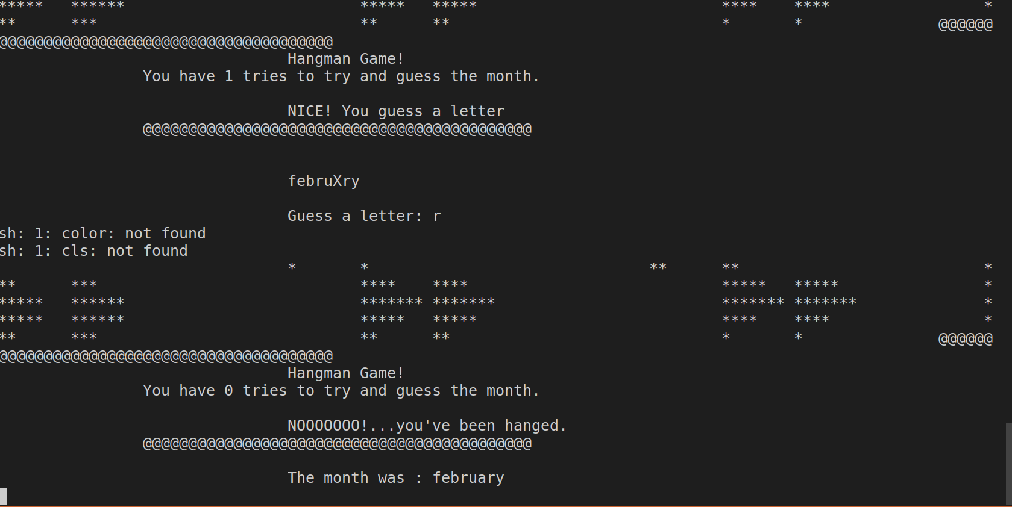
OUTPUT:-
here is sample output but sir you can run this program on your computer to check whether it is working or not.

